Current Eventos on the Twitters

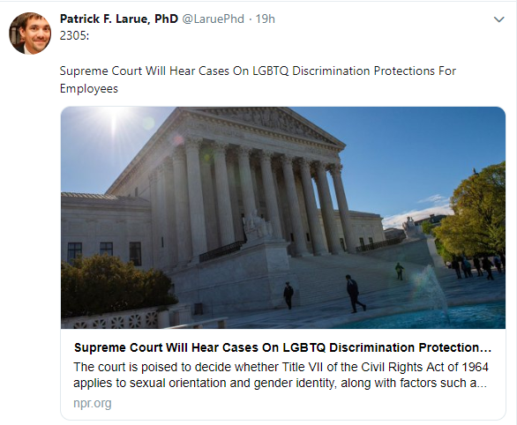

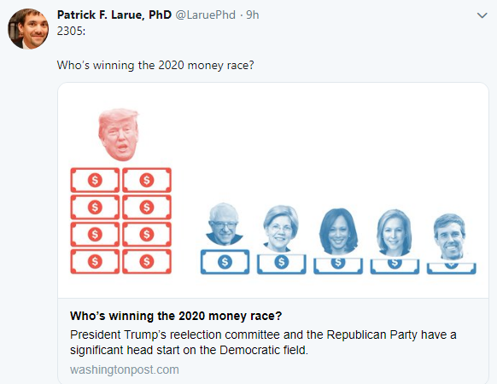

**LGBTQ ARTICLE**

3 cases that ask if anti-discirmination laws should apply to LGBTQ in the workplace

”Two of the cases — **Bostock v. Clayton County**, **Georgia, and Altitude Express, Inc. v. Zarda** — were consolid ated because both include claims that employers discriminated on the basis of sexual orientation. A third — R.G. & G.R. **Harris Funeral Homes v. EEOC** — involves the question of whether existing discrimination laws apply to transgender workers.” - Writs of Certiora petitions granted by the supreme court on the cases. Decisions will emerge during the runup national election

**Harris Funeral Homes case** limited by the supreme court: limited to only question "whether Title VII prohibits discrimination against transgender people based on (1) their status as transgender or (2) sex stereotyping" under the 1989 decision in the *Price Waterhouse v. Hopkins* case. Title VII = part of civil rights act (1964)

Lower courts divided in the eligibility of discrimination protection for LGBTQ.

-**Gerald Lynn Bostock**: Gay man discriminated and turned away at the court of appeals. 11th circuit 9-2 voted against Bostock, Judge Rosenbaum sides with Bostock

**TRUMP ARTICLE**

“President Trump’s reelection committee and the Republican Party have a significant head start on the Democratic field.” - Trump started fundraising after his 2016 election with loyal fan base support.

“The large Democratic field has been focusing heavily on trying to attract a wave of donations from people giving less than $200, partly because the Democratic National Committee will be counting each candidate’s overall number of donors to help determine who can participate in the first debate this summer. Small-dollar contributions also are considered a measure of grassroots support”

4/3/19

**Levels of Election**

* Between Cycle
  + Presidential
    - Every 4 years
    - Congress
      * The Whole House of Representatives
      * And 1/3 Senate
  + Midterm elections
    - Congress
      * The whole house of reps
      * And 1/3 of the senate
  + The president has salience
* Within Cycle
  + Primary
  + General
  + Runoff

**Election Types**

* Primary - simple majority vote wins
  + - Party level election
    - Who is going to be the number one contender for that office
    - If you don’t win the primary you don't get to even run
* General - simple majority vote wins
  + Who wins the seat
* Runoff - simple majority vote wins
  + *Take top two from previous election
  + Run against each other
  + Voter turnout drops significantly

4/8/19

Electoral Systems have Rules

**Electoral Formula**

* Plurality - when you have more votes
* Majoritarian - simple majority, i.e. 50% plus 1 vote
* Proportional - winner determined by proportion of vote

**District Magnitude**

1. Single Member District
   1. District magnitude of 1
   2. Example:
      1. US House
      2. TX has 36 districts
      3. Each has 1 seat in the house
2. Multi-Member District
   1. District magnitude of 2 or more
   2. Almost always **proportional** systems
   3. Example:
      1. US Senate
      2. TX has 2 seats in the senate

Remainders and percentages of votes. What to do with them?

* Quota method - allocate remainder to person with highest decimal point
* Divisor method- when each state's modified quota is rounded down and all are added, the total number is exactly the number of seats to be allocated

**Rules Translate into Systems**

1. Majoritarian
   1. Pluriturian / Majoritarian
   2. Single Member District
2. Proportional
   1. Proportional Representation Method
   2. Multi-Member District
3. Mixed

4/10/19

Political Parties – an organized group of citizens that seek to achieve a common set of goals by electing members to positions in government

**Organizational Structure of Parties**

**Precinct – lowest level**

* Delegate nomination and selection for national level
* Resolution
* Selection of people who will elect the electoral college
* Responsibilities
  + Local mobilization
    - Voter registration card tells you where to go vote
    - Theoretical role is to mobilize people
  + Volunteer recruitment
  + Representation on county executive committee
* Precinct convention
  + Delegate nomination and selection
  + Precinct chooses a delegate to represent at the county convention

**County Level - most important convention, it elects people that do the stuff**

* Headed by a county chair
* Also managed by a county executive committee's
* Responsibility
  + - Local Mobilization
    - Volunteer recruitment
    - Local funding
    - Administer primary election (printing ballots)
    - Party level election
    - Accept paperwork for political candidates
* County Convention
  + - County chooses delegate to represent at state convention
    - Resolutions

**State Level - most stuff happens here**

* Headed by a state chair and vice-chair
* Selected by delegates from the
  + Major fundraising
  + Political recruitment
  + Accept paperwork for political candidates
* State Convention
  + - Delegate nomination and selection for national level
    - Resolution
    - Selection of presidential electors
      * This is the electoral college

**National Level - most salient**

* Headed by a national chair and co-chair
* Also managed by national executive committee
* Responsibilities
  + - National party policy
    - Presidential election strategy (and down-ballot)
    - Advertising campaign
    - Major fundraising
* National Convention
  + Nominate President and VP

**Common Goals/Ideology**

4/12/19

Interest Groups: an organized group of citizens that seek to achieve a common set of goals by influencing elected representatives in government

Types of Goods

* Public
* Private

Classification based on two characteristics

* Excludability
  + Can prevent someone from using if they don’t pay (private)
  + Non-excludable: it’s free (public)
* Rivalry
  + Subtraction of a good if used (private)
  + Non-rival: water, sunlight (public)

Pluralism - system where interest groups must compete in order to achieve a goal

Corporation - system where interest groups must coordinate in order to achieve a goal

Lobbying - mechanism that influences government

Political Action Committee (PACs)

* Trying to influence people to vote for someone
* They raise and spend money
* There are limits

`Established by FECA (1971)

* Happened after Watergate
* Limited
  + Contributions to candidates
  + Expenditures by candidates
  + Expenditures by independent groups
* Disclosure and record keeping requirements
* Public campaign funds - check box on tax form to donate $3 of your taxes to a campaign
* Lawsuit

Buckley v Valeo (1976)

* Synopsis
* Rule in question
  + FECA provisions
* Supreme Court Decision
  + Constitutional
    - Limited contributions to candidates
    - Disclosure and record keeping requirements
    - Pulled campaign funds
  + Unconstitutional
    - Limited expenditures by candidates
    - Limited expenditures by independent groups
  + It was significant because it introduced the notion that spending money on behalf of the candidate or political party is a form a protected speech.

4/15/19

PAC's

* Group’s purpose is to raise and distribute money to political campaigns
* Established by FECA
  + Constitutional
    - Limited contributions to candidates
    - Disclosure and record-keeping requirements
    - Public campaign funding
  + Unconstitutional
    - Limited expenditures

Citizens United v FEC (2010)

* Preliminaries
  + Citizens united is a non-profit group
  + Released Hillary: the Movie right before the 2008 democratic presidential primary election
  + FEC prevented airing of movie and relevant advertisements saying that corporations cannot fund "electioneering communication"
    - Any form of political speech that promotes or slanders one candidate
  + Citizens United sued, saying that this was a violation of first amendment free speech protections
* Results
  + Corporations have the same free speech protection as people
  + Corporations are not restricted in independent expenditures (not electioneering communication)
  + A new class of organization is created with different expenditure rules in order to account for citizens for Citizens United
  + These are known as Super PAC's (independent expenditure-only committees)

CONGRESS

* Established in article 1 of the constitution
  + Bicameral legislature
  + House - 435 members, senate -100
  + Membership eligibility requirements
    - House
      * Age 25
      * Citizen for 7 years
      * Live in the state
    - Senate
      * Age 30
      * Citizen for 9 years
      * Live in the state
  + Terms of office
    - House - 2 years
    - Senate - 6 years

4/17/19

NO NOTES FOR THIS DAY DUE TO HAILGATE

4/19/19

House Impeachment:

* Know the process and how to move forward at each phase
  + i.e. number of votes, who is involved, etc.
  + Simple majority votes to move to Senate trial, upon Senate trial president can be impeached with ⅔ vote
* Treason, bribery
* <https://www.nytimes.com/2017/05/17/us/politics/how-the-impeachment-process-works-trump-clinton.html>

Senate Trial:

* Criminal Trial
* Chief Justice as presiding judge
* Senate members serve as jury

Stats of impeachments in US

* 2 presidents
* 15 judges
* 1 senator
* 1 cabinet member
* 8 judges

How a bill becomes law (Can start in either House, i.e., Congress or Senate)

1. Intro
   1. Bill introduced in the House
   2. Assigned a number by the Clerk
   3. Sent to Speaker of House
2. Referral
   1. Speaker of House reads intro
   2. Speaker send to appropriate committee to handle the bill
3. Committee (most Bills die here)
   1. Ranges from 10-20 people
   2. Refers bill to subcommittee
      1. Achieves more specialized attention
      2. Markup phase of text of the Bill
         1. Vote on changes
      3. Give bill back to full committee
   3. Vote as entire committee on the Bill, after it passed the subcommittee
4. Floor (whole process takes a month, at least)
   1. Consideration
      1. Every member of House gets 10 minutes to debate the Bill
   2. Amendments
      1. If committee allows them, House can modify text
      2. Each amendment must be voted on independently
      3. Simple majority (218 votes)
   3. Final Vote
      1. Simple majority
   4. House Version of the Bill
5. Other House (Senate or Congress)
   1. Repeat steps 1 - 4 in the other House
   2. Everything is exactly the same EXCEPT
      1. Senators can debate bills for an unlimited amount of time
         1. Filibuster
         2. Goal
            1. kill bill
            2. create concessions of some type
         3. Lax rules
            1. Senate rules allow for breaks
            2. Yield time to a fellow colleague to carry the floor debate
6. Conference committee
   1. Conference version
      1. Goes back to House and Senate Floor
7. President

4/22/19

Head of State

* Chief of Diplomats for the country

Head of Government

President

* Head of state held directly accountable by the public
* Requirements
  + 35 years of age
  + Born on US Soil "natural born"
    - Jus soli, natural soil
      * Borshington Dn in the 50 states
      * Wa.C
      * Anything that’s in possession of the U.S
    - Jus Sanguinis, Natural Birth by blood
      * As long as one of the parents is a US citizen the child is one as well
  + Resident for 14 immediate, consecutive years
* Terms of office
  + 4 years
  + 2 elected terms

Parliamentary system

* Head of the government they are held indirectly by the public
* Parliament elects the PM
* Election whenever they want, as long as it's after 5 years

6 areas of power

**Legislative power**

* Sign Bill
  + If they sign it becomes law
* Veto bill
  + This bill will not become law
  + Can go back to the house/senate and override it with a 2/3 majority
* Do nothing
  + Take no action
  + After 10 days, it will become law
  + Pocket veto
    - Only can be used at the end of the congressional session
      * End of calendar year

**Message power**

* The president's ability to outline their agenda
  + What the president wants congress to do every year
* MUST give a state of the union address at LEAST once a year

**Executive power**

* Organizes the government
  + Appointments
    - Gives people jobs
    - Organizes government bureaucracy
  + The Plum book
    - List of these jobs is the plum book

**Military power**

* Constitutionally provided power for the president to be the commander chief of the military
* Congress has the ability to declare war
  + Then the president has the ability to choose what to do

**Judicial power**

* Clemency
  + Ability for the president to dictate judicial outcomes after the trial
    - Pardons
      * As if you never went to court to begin with
    - Commutations
      * Get out of jail early, but record still stands

**Diplomacy power- chief diplomat or commander in chief (power to make treaties, executive governments, power of recognition when receiving diplomats from another country)**

4/24/19

The Cabinet

4/26/19

4/29/19

Exam 3 Review

**Citizens United**

**SUPER PACS**

**PACS**

**FECA**

5/1/19

Exam 3